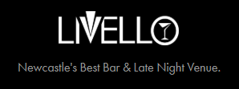

PARTY PACKAGES
MINIMUM NUBERS 50

BUFFET PACKAGE
EXCLUSIVE HIRE OF SELECTIVE AREA
ARRIVAL GLASS OF PROSECCO
FINGER BUFFET
RESIDENT DJ
FROM £34.95 PER PERSON

CANAPES PACKAGE
EXCLUSIVE HIRE OF SELECTIVE AREA
ARRIVAL GLASS OF PROSECCO
CANAPES THREE PER PERSON
RESIDENT DJ
FROM £29.95 PER PERSON

PARTY PACKAGE
EXCLUSIVE HIRE OF SELECTIVE AREA
ARRIVAL GLASS OF PROSECCO
FINGER BUFFET
RESIDENT DJ
2 DRINKS TOKENS PER PERSON
FROM £44.95 PER PERSON

